**Task 19: Setup minikube at your local and explore creating namespaces (Go through official documentation)**

1. **Launch an ec2 with t2. medium:**

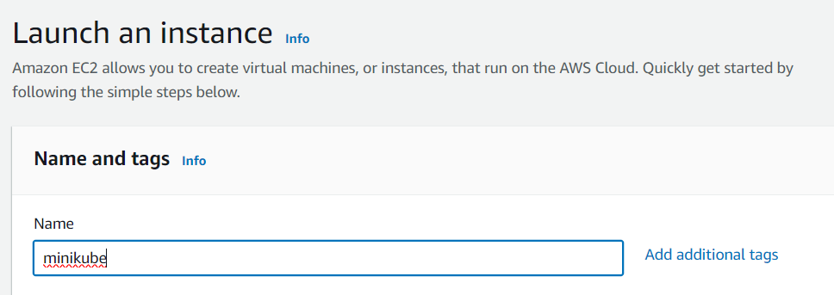

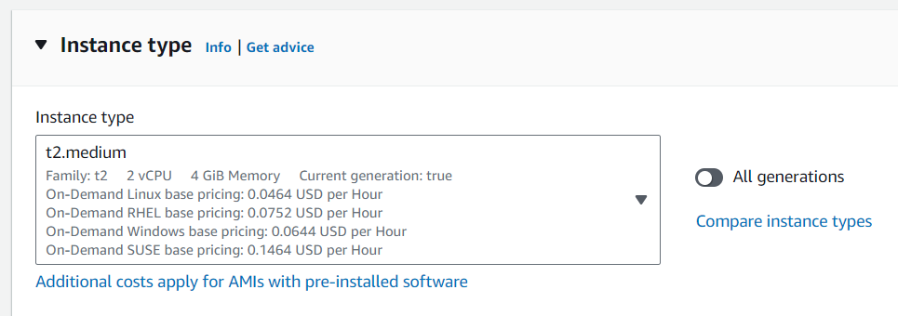

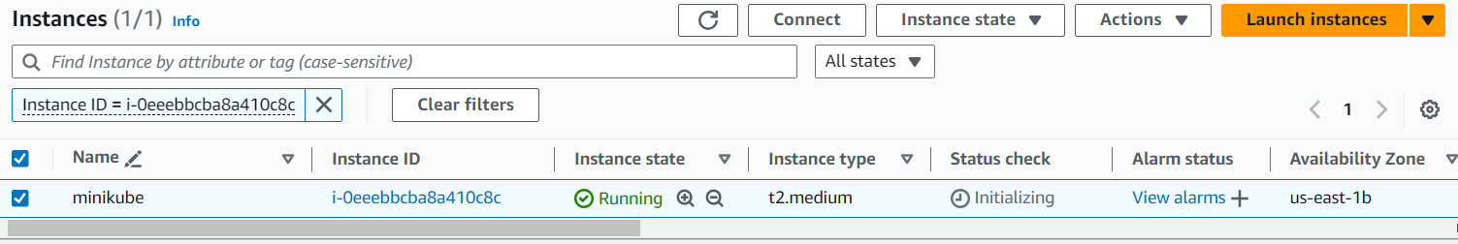

1. **Install docker:**

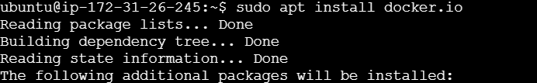

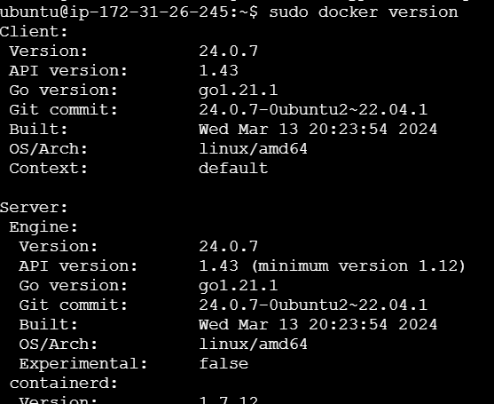

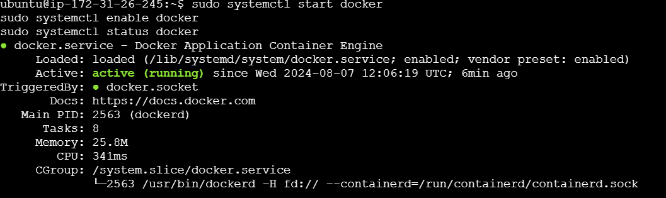



1. **Install kubectl:**

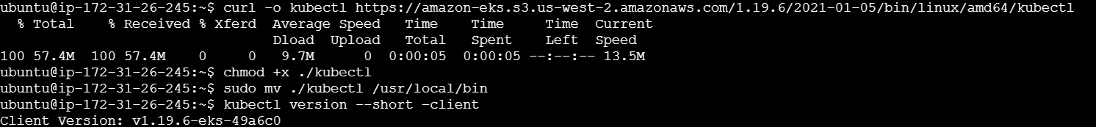

1. **Install eksctl:**



1. **Install minikube:**



1. **Minikube start:**

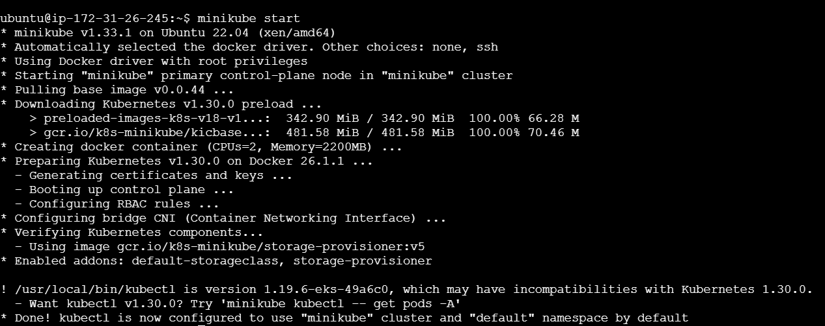

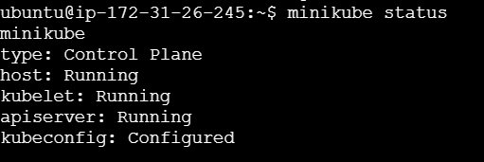

1. **Namespace:**

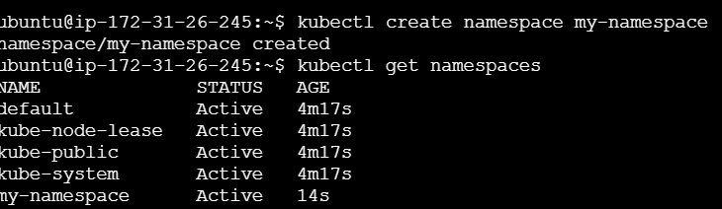

1. **Namespace.yaml file:**



